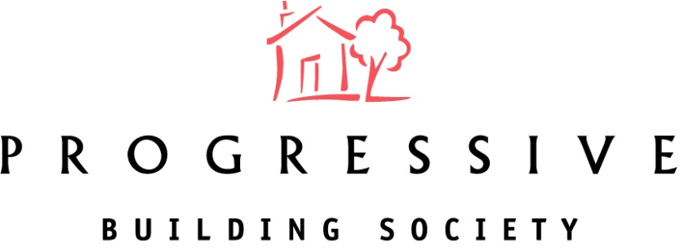

2022 Annual General Meeting Results
The 107th Annual General Meeting (AGM) of your local building society took place on Thursday 28th April 2022 at Meeting Room 2, ICC Belfast, 2 Lanyon Place, BT1 3WH.
The Society would like to thank all Members who participated in the 2022 AGM vote for the overwhelming support given to the Board's recommendations.
Progressive Building Society pledged to donate 20p for every postal vote and £1 for every online vote cast and this has resulted in a donation of £2,000 to Northern Ireland Chest Heart & Stroke.
The results of the Resolutions proposed at the AGM are shown below:
Ordinary Resolution | For | Against | Withheld | % For
To receive the Directors’ Report, Annual Accounts and Annual Business Statement for the year ended 31st December 2021. | 4762 | 28 | 22 | 99.4%
To approve the re-appointment of Deloitte as Auditors. | 4716 | 68 | 28 | 98.6%
To approve the Report on the Directors’ Remuneration. | 4584 | 178 | 50 | 96.3%
Re-Election of Directors

Darina Armstrong | 4703 | 86 | 23 | 98.2%
Karen Furlong | 4697 | 88 | 27 | 98.2%
Gerard McGinn | 4691 | 90 | 31 | 98.1%
Election of Directors
Clare Guinness | 4699 | 83 | 30 | 98.3%
Stephen Mitcham | 4701 | 75 | 36 | 98.4%

